# Industry Momentum Based Trading Strategy

**Xiner Zhou**

**HUID: 10945046**

**Email:** [**xzhou@hsph.harvard.edu**](mailto:xzhou@hsph.harvard.edu)

**Harvard University**

**Fall 2016 • Stat 107: Introduction to Business and Financial Statistics**

**Professor Michael Parzen**

**Due: December 8th, 2016**

**Abstract**

There is extensive empirical evidence of intermediate term stock momentum, and the observed stock momentum could be attributed to industry momentum. Compared with trading multiple stocks, trading strategy based on sector funds may be cost effective and more practical for individual investors.

As a replication and extension of the chapter about “Momentum in Industry Portfolios” in the book “Beyond the Random Walk” by Vijay Singal, the paper implemented industry-momentum-based trading strategies using Fidelity sector funds, from 2007-2016, and examined a comprehensive range of estimation and holding periods, from 1-month to 12-month, and all possible number of winning sectors to hold, from top 1 to all sectors. To implement this trading strategy for individual investors in practice, Fidelity sector funds is the best candidate, as it have costless intrafamility transfer cost, given holding more than 30 days.

The best industry-momentum-based trading strategy is the “1-month, 1-sector” system, which yields an average CAGR of 64.3%, compared with S&P 500 index’s return of 18.4%, it yields an abnormal return of 45.9%.

The results presented in this paper also show that, there is a significant decline of returns while increasing the length of estimation and holding periods, and also a significant decline of returns while increasing the number of winning sectors to hold.

In general, industry-momentum-based trading strategies are profitable compared to holding broader market index. However, less than 6-month estimation and holding periods should be adopted, as industry-momentum might disappear after longer time frame.

However, taking risk into account, the industry-momentum-based trading strategies may not be ideal, given S&P 500 yields relatively high Sharpe ratio. The performance of trading strategies needed further exploration using different risk measures.

In summary, the industry-momentum-based trading strategy is still profitable today. The explanation of persistent anomaly needed insights from behavioral finance.

**Introduction**

The efficient market hypothesis (EMH) states that asset prices fully reflect all available information. However, it has been disputed both empirically and theoretically. An efficient market will reflect newly available information in a few minutes, even seconds. However, if only half of that information is reflected in the stock price immediately and the remaining half takes several days, then the market is less than fully efficient. Inefficiency opens up profitable opportunities that take advantage of valid anomalies or mispricing, if appropriate trading strategy is implemented. More important than individual monetary reward, trading based on anomalies will improve market efficiency with the associated benefits of superior resource allocation and enhanced social welfare.

There is extensive empirical evidence to suggest profitability of trading strategies based on stock momentum – buying and holding winner stocks. Momentum in stock returns is the tendency for well performing stocks to continue perform well and for poor performers to continue to perform poorly. This positive serial correlation has been documented for US common stock returns for holding periods in the 3- to 12-month range. Jegadeesh and Titman (1993) examined the strategy of selecting US stocks on the basis of their performance in the previous six months and holding the portfolio for six months realized abnormal returns of 12 percent a year.

However, Moskowitz and Grinblatt (1999) attributed the bulk of the observed momentum in intermediate-term individual stock returns to industry momentum. The authors documented a strong and prevalent momentum effect in industry components of stock returns which accounts for much of the individual stock momentum anomaly. Once returns are adjusted for industry effects, momentum profits from individual stocks are significantly weaker and statistically insignificant.

To exploit the industry momentum, Moskowitz and Grinblatt proposed a zero investing strategy that went long on past sector mutual funds and short on past losing ones for the holding period. They explored this strategy for various length of estimation period and hold period, but concentrated their analysis on six-month estimation and six-month hold periods. Profits average 0.43 percent a month. Because shorting can present problems for investors, they identified what proportion of the return came from winning portfolios and what proportion came from losing portfolios. Of the 0.43 percent a month, 0.37 percent came from winners and the remaining 0.06 percent came from losers.

Therefore, this paper explores one mechanism for capturing industry momentum profits – trading strategies using industry-sector mutual funds. The trading strategies examined in this paper will be a combination and extension of “Industry Momentum and Sector Mutual Funds” Edward O’Neal (2000) and “Beyond the Random Walk: A Guide to Stock Market Anomalies and Low-Risk Investing” by Vijay Singal. The primary goal of the analysis is to implement viable industry momentum based trading strategies and compare their performance with S&P 500 index, using most up-to-date data.

**Methods**

There are many fund families, such as Fidelity, Rydex, ProFunds, Icon, and Invesco, offer sector funds. While trading strategies based on a large number of funds is useful in spanning the entire industry and minimizing the risk of any one industry, many funds are inconvenient and costly to trade. It’s especially not desirable for small investors to trade dozens of funds over five or six different mutual fund companies. Therefore, the analysis here uses only Fidelity sector funds, rather than all fund families, for two reasons. First, Fidelity has forty-one sector funds in twenty-three industries, which is the largest coverage fund family among all. Second, Fidelity allows costless exchange through their website provided the sector fund is held for at least thirty days. The zero cost intra-family fund transfer feature is mostly desirable for reducing transaction cost, especially for intensive switching between funds.

**Trading Process and Strategy Implementation with Fidelity’s Sector Funds**

Step 1: There are forty-one sector funds offered by Fidelity currently, as shown in Table 1 below. Among them, there are five funds not applicable to implement (highlighted), due to either no data available through R or no appropriate industry assignment. With the final thirty-five sector funds, I assign them into twenty-three distinct industries, as shown in Table 2.

Step 2: Obtain the historical prices and monthly return from January 1, 2007 through December 3, 2016 (as of the date the paper was written), for a ten-year interval. Previous studies mostly used data prior to 2000, this study intends to capture evidence in a new time frame that no other studies have been looking at.

Step 3: There are at least two parameters we can tune to get an optimal trading strategy: the length of estimation and holding periods (let them be the same to simplify, further exploration could let them differ), such as 1-month, 2-month, 3-month, and so on up to 12-month; the number of winning sectors we will hold, such as the top 1 wining sector, top 2 winning sectors, and so on up to all 23 sectors. As an innovative approach, I will examine all the 12 by 23 combinations strategy. For example, with the estimation and holding periods as 3-month, and the number of top winning sectors as 1, the specific trading strategy would be:

* Calculate the compound growth rates of January-March 2007 for each fund;
* Assuming equal investing within industries, take the average of the calculated compound growth rate to get industry compound growth rate;
* Rank industry by the calculated compound growth rate, and keep the top 1 winning sector, and find out associated funds within this sector;
* Calculate the compound growth rates of April-June 2007 for each winning fund;
* Assuming equal investing, take the average of the calculated compound growth rates as the final return for this investing period, and annualize it, store it;
* Repeat the above process starting from April-June 2007 as estimation period, and so on.

Step 4: After loop through all possible trading strategies, and get ten-year’s compound annualized growth rate (CAGR), calculate the mean, standard deviation, and Sharpe ratio. Compare them with S&P 500 Index. Results are shown in Table 3, in the “Results” section.

Step 5: The innovative part of the paper is to explore the effect of the estimation and holding period and the number of winning sectors to hold, both visually using graphics and statistically using regression models. Results are shown in Table 3, Figure 1-3, and Model 1-3, in the “Results” section.

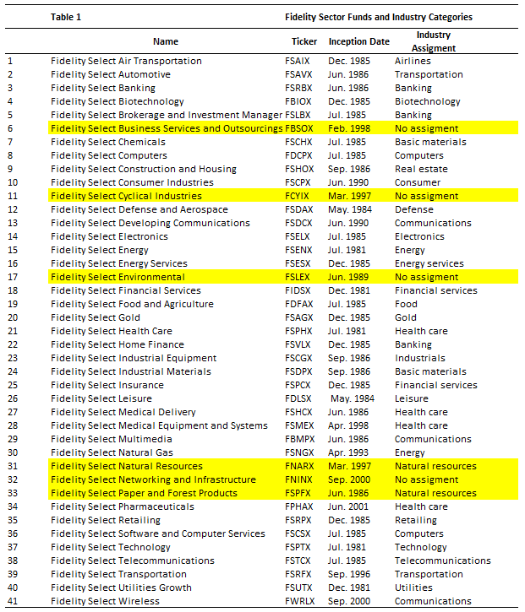

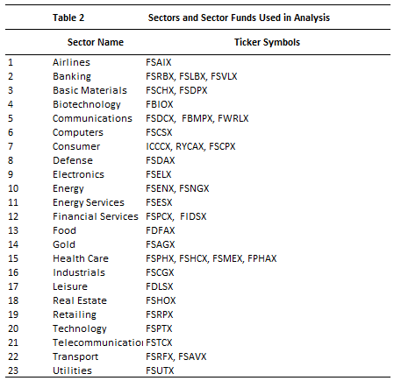

**Results**

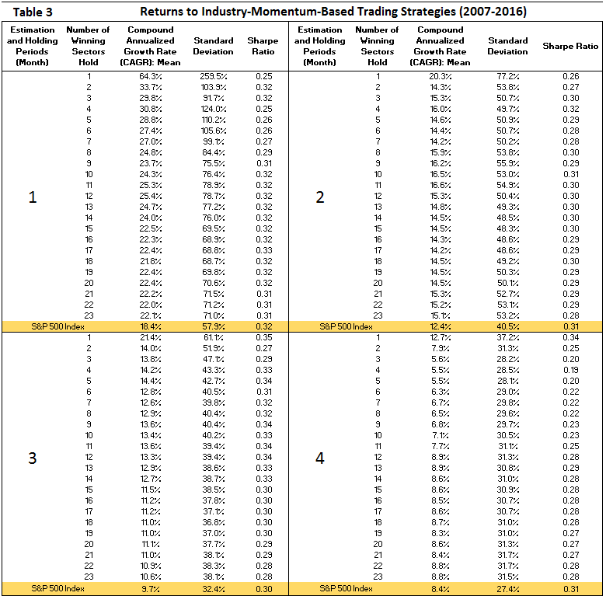

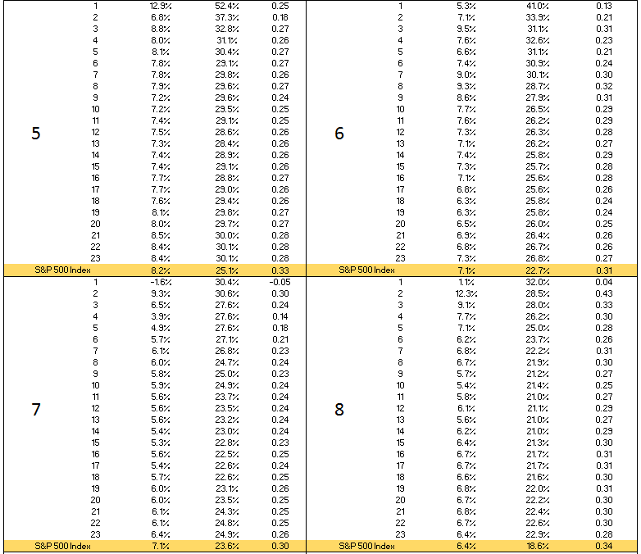

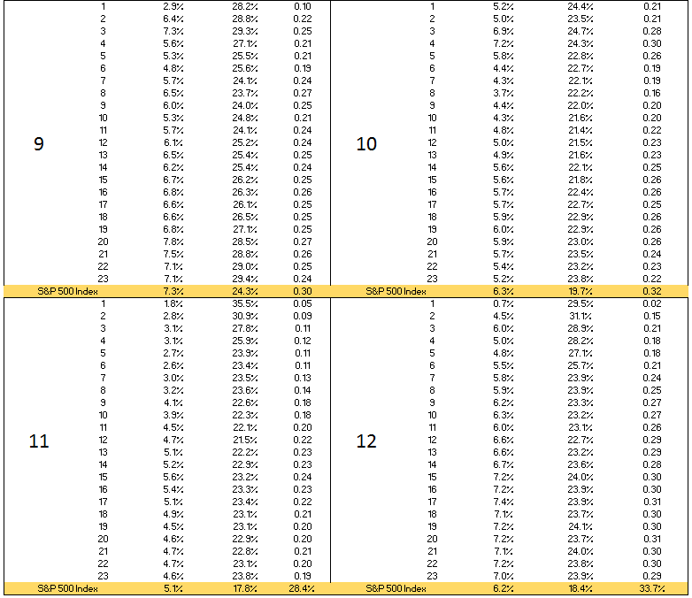

The best industry-momentum-based trading strategy seems to be the one with 1-month estimation and holding periods, and hold only the top 1 sector, which yields an average CAGR of 64.3%, although associated with great risk of 259.5% standard deviation.

In terms of general trend, there appears to be a decline of returns while increasing the length of estimation and holding periods, and also a decline of returns while increasing the number of winning sectors to hold. To better understand the optimal strategy, several visual graphics are presented below.

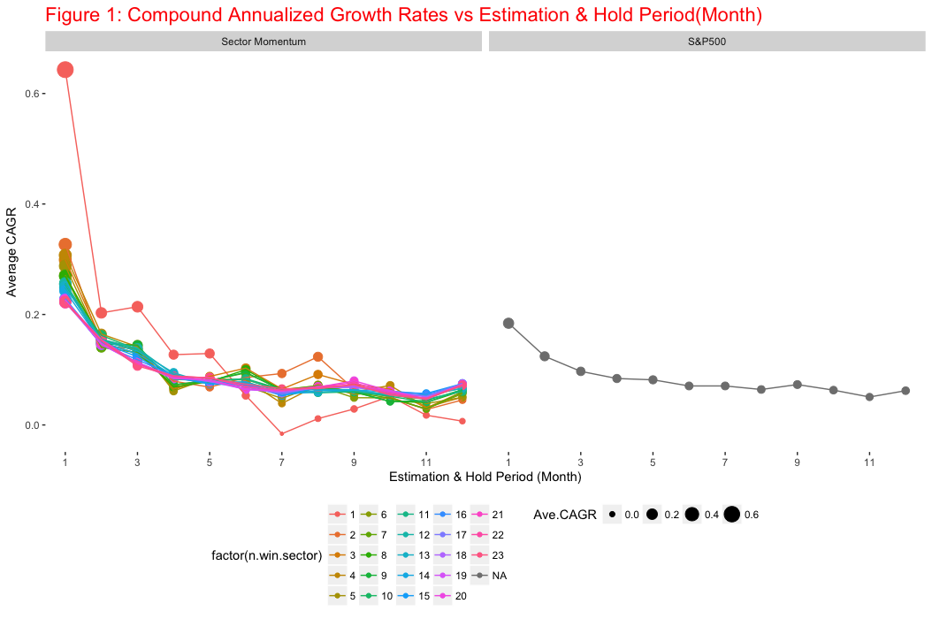

Figure 1 explores the relationship between CAGR and the length of estimation and holding periods, stratified by the number of winning sectors to hold. It’s clear that, for any fixed number of winning sectors to hold, the longer the estimation and holding period, the less the average return is. And the highest return was given by “1-month, 1-sector” strategy, it achieves surprisingly high average CAGR among all. Overall, holding only the top 1 sector seems to be a dominant strategy overall other industry-momentum-based trading strategies and also S&P 500 index.

Compare various momentum-based trading strategies with S&P 500 index, less than 6-month estimation and holding periods have higher returns than S&P 500, in general; while more than 6-month strategies underperform S&P 500 index, in general. This might suggest that, any industry-momentum-based trading strategy should not using estimation and holding periods longer than 6 months. The reason might be that industry momentum eventually disappears after 6 months.

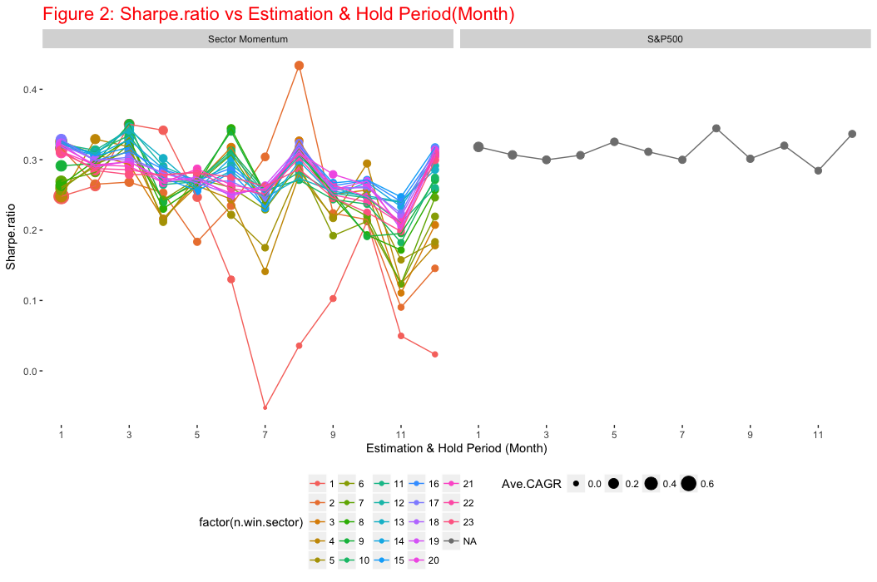

Risk is an important component of evaluating any investment strategies, especially true for momentum-based trading strategies, as the portfolio is inadequately diversified – only a few industries are selected for investment. Intuitively, industry-momentum-based trading strategies are riskier than holding a broader market portfolio, that is, S&P 500 index.

Figure 2 validates this point. Trading sector funds based on momentum do not outperform S&P 500 after accounting for risk, as measured by Sharpe Ratio. Other risk measures could be further explored in future work.

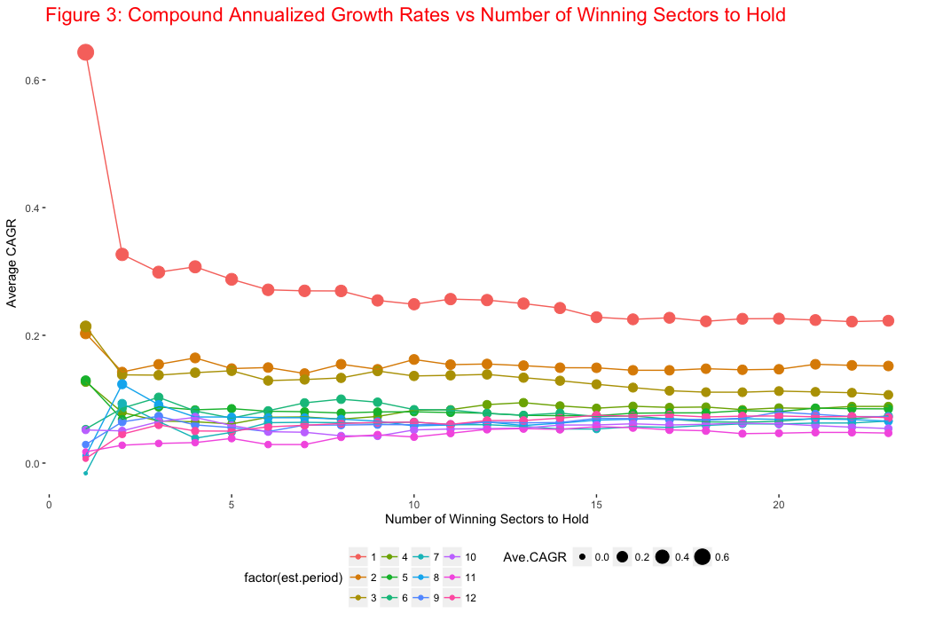

Figure 3 explores the relationship between CAGR and the number of winning sectors to hold , stratified by the length of estimation and holding periods. The more sectors held, the less returns would be. It appears that holding only the top 1 winning sector has a significant superior performance. Again, the highest return was given by “1-month, 1-sector” strategy, it achieves surprisingly high average CAGR among all.

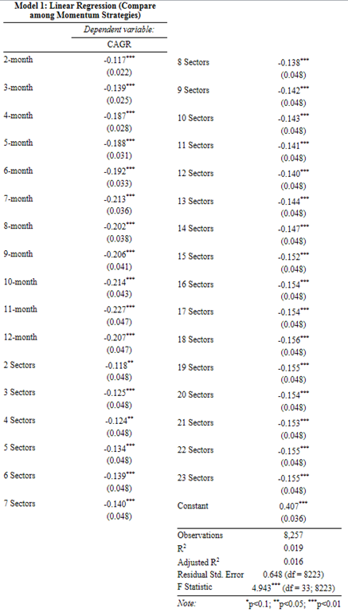

To validate the hypothesis that “1-month, 1-sector” is the optimal trading strategy, I ran a linear regression model with CAGR as the dependent variable, period and number of sectors as independent variables (categorical). Model 1 result shows that 1-month has significant higher average CAGR than any other periods, holding number of sector constant; and 1-sector also has significant higher CAGR than any others, holding period constant, as shown by the significant negative coefficients in the model

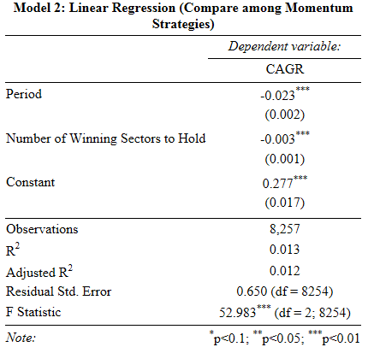

In order to quantify and test the general trend, I ran a linear regression model with CAGR as the dependent variable, period and number of sectors as independent variables (continuous). There is a significant negative trend associated with both period and number of sectors to hold. For every 1 more month as estimation and holding period, the average CAGR decreases 2.3% (<0.01), adjusting for the number of winning sectors to hold. For every 1 more sectors to hold, the average CAGR decreases 0.3%(<0.01).

This result further backs up the conclusion that, “1-month, 1-sector” industry-momentum-based trading strategy should be implemented over all others, as it outperforms significantly.

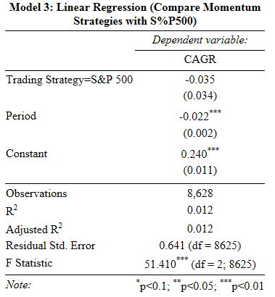

Lastly, I want to evaluate whether industry-momentum-based trading strategies are worthwhile exploring, that is, whether they outperform S&P 500, in most cases. I ran a linear regression with CAGR as dependent variable, S&P 500 vs Momentum Strategy as categorical independent variable, and period as continuous independent variable. The regression shows that S&P 500 has 3.5% lower CAGR than industry-momentum-based trading strategies, although not significant. From Table 3, we can easily imagine that shorter periods (less than 6-month) momentum-based strategies would significantly outperform S&P 500; while longer periods (longer than 6-month) momentum-based strategies would significantly underperform S&P 500. The positive and negative effects cancel each other out in this regression model.

**Conclusions and Discussion**

In this paper, I implemented industry-momentum-based trading strategies using Fidelity sector funds, from 2007-2016. It’s meant to serve as an extension and most up-to-date replication of the chapter about “Momentum in Industry Portfolios” in the book “Beyond the Random Walk” by Vijay Singal.

I examined a comprehensive range of estimation and holding periods, from 1-month to 12-month, and all possible number of winning sectors to hold, from top 1 to all sectors. The best industry-momentum-based trading strategy is the “1-month, 1-sector” system, which yields an average CAGR of 64.3%, compared with S&P 500 index’s return of 18.4%, it yields an abnormal return of 45.9%.

Previous studies didn’t examined the effect of the length of estimation and holding periods and the number of winning sectors to hold. However, the results presented in this paper show surprising evidence. Statistically speaking, there is a significant decline of returns while increasing the length of estimation and holding periods, and also a significant decline of returns while increasing the number of winning sectors to hold.

In general, industry-momentum-based trading strategies are profitable compared to holding broader market index. However, less than 6-month estimation and holding periods should be adopted, as industry-momentum might disappear after longer time frame. Specifically, momentum-based strategies with less than 6-month estimation and holding periods would significantly outperform S&P 500; while longer periods (longer than 6-month) momentum-based strategies would significantly underperform S&P 500.

The explanation of this market anomaly could be behavioral finance and inefficient market. Irrational investors often either chase winning stocks or underreact to new information. In addition, industry momentum may also occur because financial markets rely on companies and analysts who are slow in updating earnings forecasts.

In summary, the industry-momentum-based trading strategy is profitable today, and the optimal strategy would be to trade on each month and hold the previous top one winning sector. Fidelity sector funds have costless intrafamility transfer cost, given holding more than 30 days. Although holding only one sector associated with inevitably high risk. Depend on individual risk preference, one could choose to hold more than one sectors whose returns are above the mean.

**References**

Vijay Singal. 2003. BEYOND THE RANDOM WAL: A Guide to Stock Market Anomalies and Low Risk Investing.

O’Neal, Edward S. 2000. Industry Momentum and Sector Mutual Funds. Financial Analyst Journal 56(4), 37–49.

Moskowitz, Tobias, and Mark Grinblatt. 1999. Do Industries Explain Momentum? Journal of Finance 54(4), 1249–90.

Grundy, Bruce D., and J. Spencer Martin. 2001. Understanding the Nature of the Risks and the Source of the Rewards to Momentum Investing. Review of Financial Studies 14(1): 29–78.

Jegadeesh, Narasimhan, and Sheridan Titman. 1993. Returns to Buying Winners and Selling Losers: Implications for Stock Market Efficiency. Journal of Finance 48(1), 65–92.

**Appendix**

library(quantmod)

library(dplyr)

library(ggplot2)

library(stargazer)

library(PerformanceAnalytics)

library(xlsx)

### Assign Fidelity sector funds into distinct industries

# set up working directory

setwd("E:/Course Work at Harvard/Introduction to Financial Statisitcs/Final Project Sector Momentum")

# read in sector funds and industry assignment

funds<-read.csv("Sector Fund Names.csv")

funds[order(funds$Industry.Assigment),]

# industries covered

industry<-unique(funds$Industry.Assigment)

### Obtain the historical prices and monthly return

# get the monthly return for each fund and store them

return.mat<-matrix(NA,nrow = 120, ncol = nrow(funds))

colnames(return.mat)<-as.character(funds$Ticker)

for(i in 1:nrow(funds)){

ticker<-as.character(funds$Ticker[i])

price<-getSymbols(ticker, from="2007-01-01", to="2016-12-03", auto.assign = F)

return.mat[,i]<-as.numeric(monthlyReturn(price))

}

### The function Sector.Momentum

# inputs:

# from which date the trading algorithm begins: from.date

# to which date the trading algorithm ends: to.date

# estimation period: est.period

# holding period: hold.period

# number of winning sector to hold : n.win.sector

Sector.Momentum<-function(from.date,to.date,est.period,hold.period,n.win.sector){

# Initialized a place-holder for annualized returns, this will be the final return object

CAGR<-rep(NA, 120/est.period-1)

### Loop through 1st to last estimation period

for(j in 1:(120/est.period-1)){

# initialize place-holder for annualized return at each estimation period

funds$comp.ret<-rep(1,nrow(funds))

### At each estimation period j, calculate Compound Return for each fund

# temprarily store in funds$CAGR, they will change for each iteration of j estimation period

for(i in 1:nrow(funds)){

for(k in 1:est.period){

funds$comp.ret[i]<-funds$comp.ret[i]*(1+return.mat[est.period*(j-1)+k,i])

}

}

### Now, we have Compound Return for each fund during the estimation period

### select holding sectors

winning.sector<-funds%>%

group_by(Industry.Assigment)%>%

summarise(CAGR=mean(comp.ret)^(1/(est.period/12))-1)%>%

arrange(desc(CAGR))%>%

top_n(n=n.win.sector)

# select all funds within the winning sector

winning.funds<-funds%>%filter(Industry.Assigment %in% winning.sector$Industry.Assigment)%>%select(Ticker)

n.winning.funds<-length(winning.funds$Ticker)

### invest for the holding period

# select returns from previously created return matrix for those winning funds

win.return.mat<-as.matrix(return.mat[,as.vector(as.character(winning.funds$Ticker))])

# Initialize a place-holder for each winning fund's compound return during holding period

win.funds.comp.ret<-rep(1,n.winning.funds)

for(m in 1:n.winning.funds){

for(n in 1:hold.period){

win.funds.comp.ret[m]<-win.funds.comp.ret[m]*(1+win.return.mat[est.period*j+n,m])

}

}

### Now, we have compound returns for all winning funds during the holding period

# Assuming equal investing among all funds

# Calculate the final CAGR of jth estimation period:

# average of all funds' compound return, then annualize

CAGR[j]<-mean(win.funds.comp.ret)^(1/(hold.period/12))-1

}

return(CAGR)

}

### Use the function Sector.Momentum, vary estimation and hold periods, method, and number of winning sectors

est.period<-c()

hold.period<-c()

n.win.sector<-c()

CAGR<-c()

# Let estimation and hold periods to be equal, and loop through 1 to 12 month

for(i in 1:12){

# The total number of sectors is 23, we want to hold at least somewhat better than average

# Let the number of winning sectors loop through 1:10

for(j in 1:23){

CAGR.temp<-Sector.Momentum(from.date="2007-01-01", to.date="2016-12-03", est.period=i, hold.period=i,n.win.sector=j)

est.period<-c(est.period,rep(i,length(CAGR.temp)))

hold.period<-c(hold.period,rep(i,length(CAGR.temp)))

n.win.sector<-c(n.win.sector,rep(j,length(CAGR.temp)))

CAGR<-c(CAGR,CAGR.temp)

}

}

# Put them into a data.frame

momentum.CAGR<-data.frame(CAGR,est.period,hold.period,n.win.sector,method=rep("Sector Momentum",length(CAGR)))

### If buy and hold S&P500 for the same length, such as 1-month, 2-month, and so on, what is the CAGRs?

price<-getSymbols("SPY", from="2007-01-01", to="2016-12-03", auto.assign = F)

ret<-as.numeric(monthlyReturn(price))

period<-c()

CAGR<-c()

for(i in 1:12){

for(j in 1:(120/i)){

CAGR.temp<-1

for(m in 1:i){CAGR.temp<-CAGR.temp*(1+ret[i*(j-1)+m])}

CAGR.temp<-CAGR.temp^(1/(i/12))-1

CAGR<-c(CAGR, CAGR.temp)

period<-c(period,i)

}

}

# Put them into a data.frame

SP500.CAGR<-data.frame(CAGR, est.period=period,hold.period=period,n.win.sector=rep(NA,length(CAGR)),method=rep("S&P500",length(CAGR)))

### Make a Table of comparison of various strategies

all.CAGR<-rbind(momentum.CAGR,SP500.CAGR )

temp<-all.CAGR%>%group_by(method, est.period, n.win.sector)%>%

summarise(Ave.CAGR=mean(CAGR), std.dev=sd(CAGR), Sharpe.ratio=mean(CAGR)/sd(CAGR))%>%

as.data.frame()

# output to xls file

write.csv(temp,"Table 3.csv")

### Visualize

# X-axis is Estimation & Hold Period(Month), Y is CAGR

temp%>%

ggplot(aes(x=est.period, y=Ave.CAGR, colour=factor(n.win.sector)))+

geom_point(aes(size=Ave.CAGR))+

geom_line()+

theme(panel.background=element_blank(),

plot.title = element_text(size=rel(1.5),colour = "red"),

legend.position = "bottom")+

ggtitle("Figure 1: Compound Annualized Growth Rates vs Estimation & Hold Period(Month)")+

scale_x_continuous(breaks=seq(1,12,2))+

xlab("Estimation & Hold Period (Month)")+

ylab("Average CAGR")+

facet_wrap(~method)

# X-axis is Estimation & Hold Period(Month), Y is Sharpe Ratio

temp%>%

ggplot(aes(x=est.period, y=Sharpe.ratio, colour=factor(n.win.sector)))+

geom_point(aes(size=Ave.CAGR))+

geom_line()+

theme(panel.background=element_blank(),

plot.title = element_text(size=rel(1.5),colour = "red"),

legend.position = "bottom")+

ggtitle("Figure 2: Sharpe.ratio vs Estimation & Hold Period(Month)")+

scale_x_continuous(breaks=seq(1,12,2))+

xlab("Estimation & Hold Period (Month)")+

ylab("Sharpe.ratio")+

facet_wrap(~method)

# X-axis is Number of Winning Sectors to Hold

momentum.CAGR%>%

group_by(est.period, n.win.sector)%>%

summarise(Ave.CAGR=mean(CAGR))%>%

ggplot(aes(x=n.win.sector, y=Ave.CAGR, colour=factor(est.period)))+

geom_point(aes(size=Ave.CAGR))+

geom_line()+

theme(panel.background=element_blank(),

plot.title = element_text(size=rel(1.5),colour = "red"),

legend.position = "bottom")+

ggtitle("Figure 3: Compound Annualized Growth Rates vs Number of Winning Sectors to Hold")+

xlab("Number of Winning Sectors to Hold")+

ylab("Average CAGR")

### Regression

# From the above visualization, we could hypothesis that, the length of estimation and hold periods has a negative effect on returns, even adjusting for number of winning sectors to hold; and only holding the top 1 sector is better than any other strategies, and the effect of number of sectors to hold may be slightly negative or even non-significant, after accounting for estimation and hold period.

fit1<-lm(CAGR~factor(est.period)+factor(n.win.sector),data=momentum.CAGR)

fit2<-lm(CAGR~est.period+n.win.sector,data=momentum.CAGR)

fit3<-lm(CAGR~factor(method)+est.period,data=all.CAGR)

stargazer(fit1,out="fit1.htm",title="Model 1: Linear Regression (Compare among Momentum Strategies)",

covariate.labels = c("2-month","3-month","4-month","5-month","6-month","7-month",

"8-month","9-month","10-month","11-month","12-month",

"2 Sectors","3 Sectors","4 Sectors","5 Sectors","6 Sectors",

"7 Sectors","8 Sectors","9 Sectors","10 Sectors","11 Sectors",

"12 Sectors","13 Sectors","14 Sectors","15 Sectors","16 Sectors",

"17 Sectors","18 Sectors","19 Sectors","20 Sectors","21 Sectors",

"22 Sectors","23 Sectors"))

stargazer(fit2,out="fit2.htm",title="Model 2: Linear Regression (Compare among Momentum Strategies)",

covariate.labels = c("Period","Number of Winning Sectors to Hold"))

stargazer(fit3,out="fit3.htm",title="Model 3: Linear Regression (Compare Momentum Strategies with S%P500)",

covariate.labels = c("Trading Strategy=S&P 500","Period"))